7.2 Testing record template
Testing question | Yes/No | Notes / evidence
Does the prototype open or start correctly? | Yes | 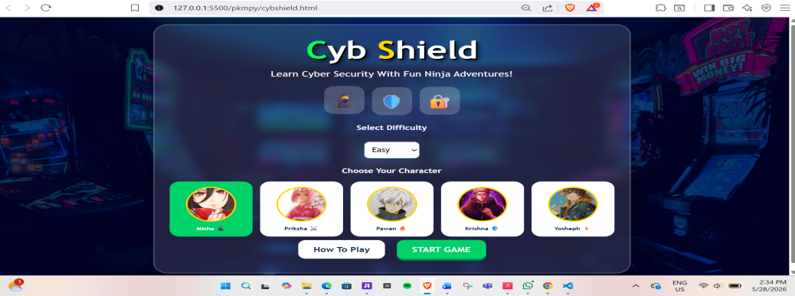
Is the welcome/title screen clear? | Yes | The title is clear with the game title appearing cleary  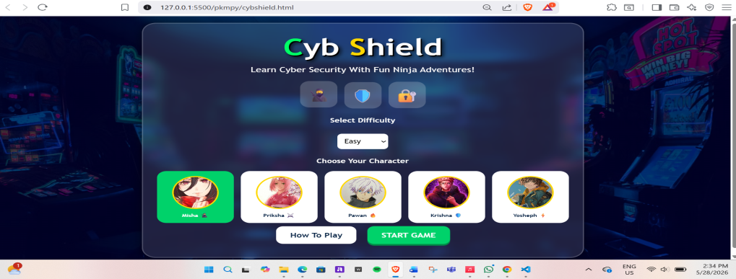
Are the instructions easy to understand? | Yes | 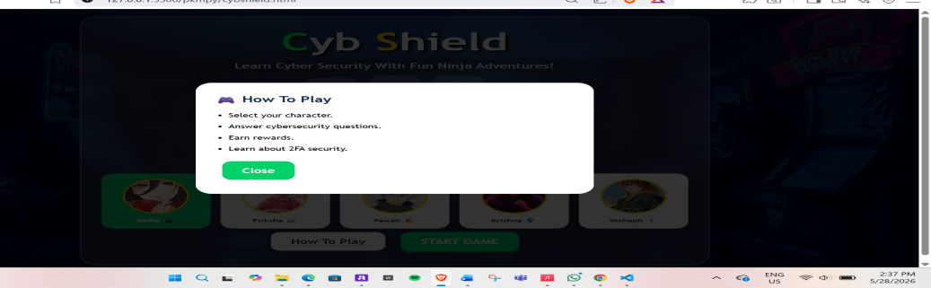
Can the player understand what to do next? | Yes | The instructions after completing any level is clear  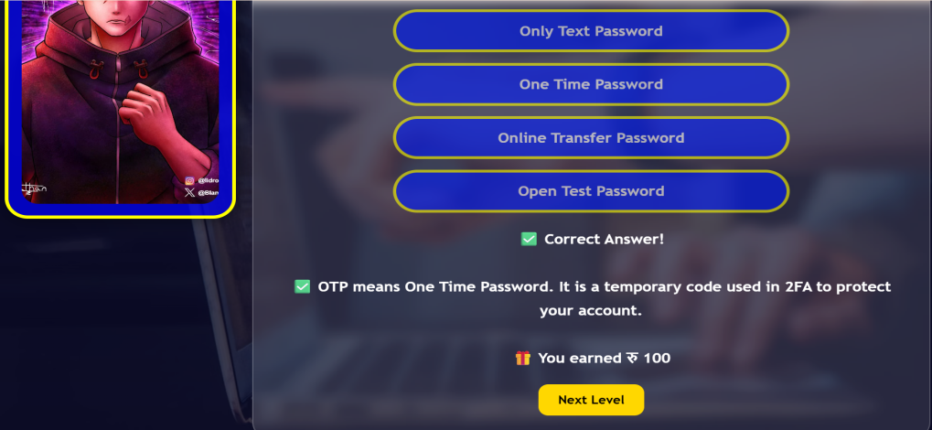
Do the choices/buttons/interactions work? | Yes | You can see the option changing its color upon hovering the mouse over it  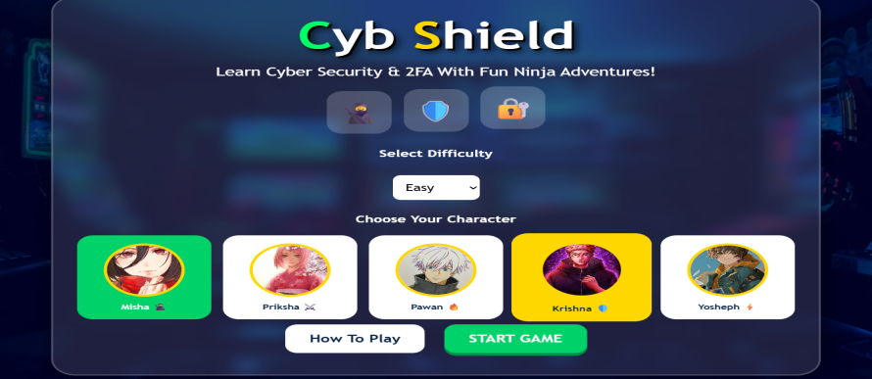
Does the correct answer show correct feedback? | Yes | 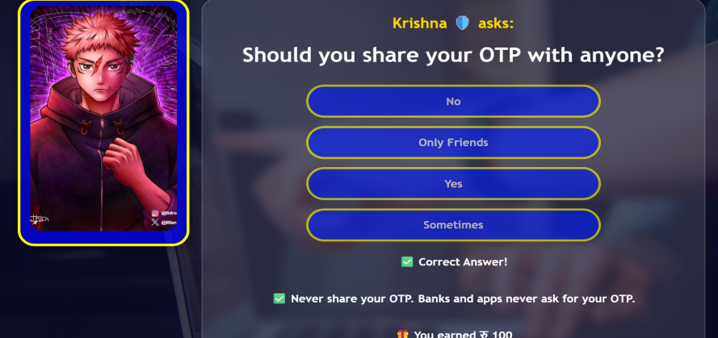
Does the wrong answer show helpful feedback? | Yes | /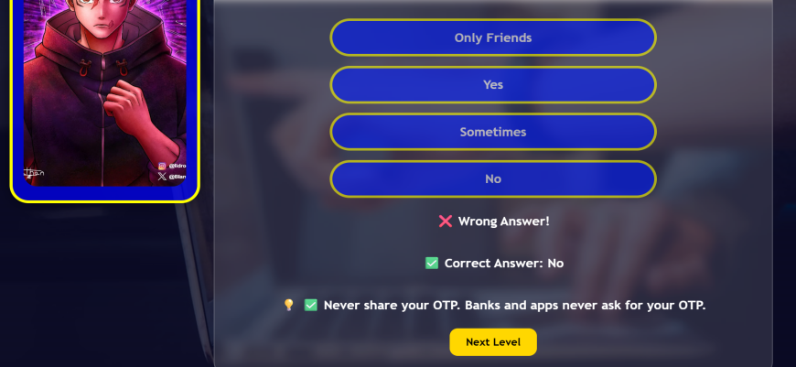
Does the feedback explain the cyber-safety lesson? | Yes | 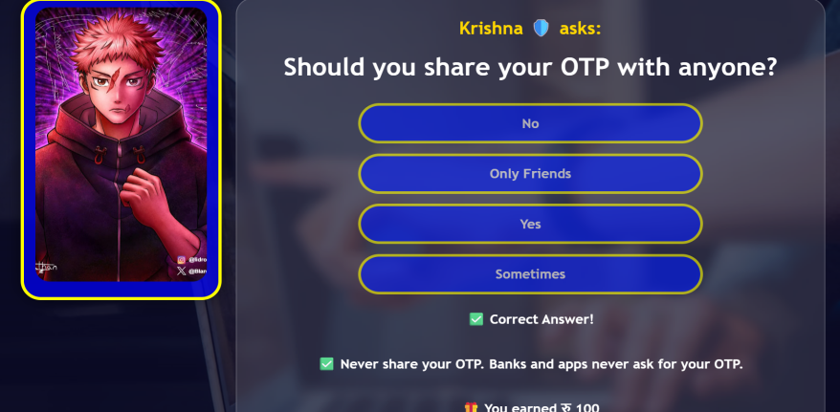
Is there a reward, score, star, level, or success message? | Yes | 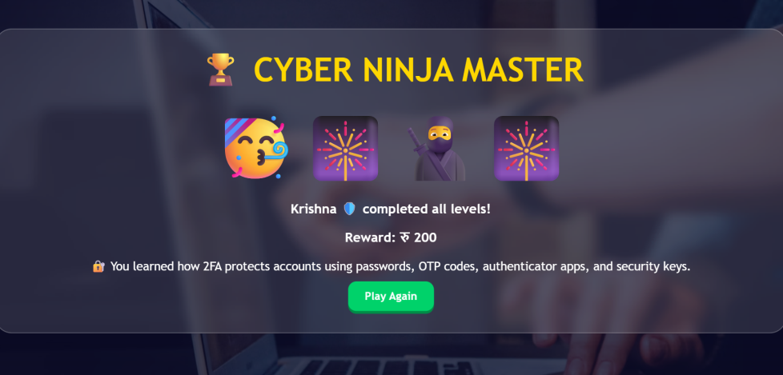
Is the design suitable for the target audience? | Yes | The design is simple with children friendly with interesting character choices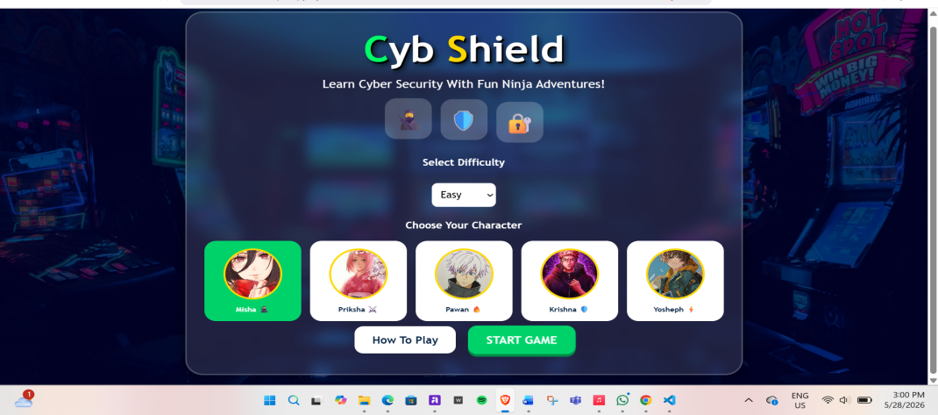
What needs improvement before submission? |  | The feedback

